1. (5 points) Consider the problem of constructing crossword puzzles: fitting words into a grid of intersecting horizontal and vertical squares. Assume that a list of words (i.e. a dictionary) is provided and that the task is to fill in the squares using any subset of this list. Go through a complete goal and problem formulation for this domain and choose a search strategy to solve it. Specify the heuristic function, if you think one is needed. For help with this problem see chapter 4, Informed Search and Exploration.

2. (10 points) Consider the two-player game described below (Figure 1).
- Draw the complete game tree, using the following conventions:
  - Write each state as (s_{A}, s_{B}) where s_{A} and s_{B} denote the token locations.
  - Put each terminal state in square boxes and write its game value in a circle next to it.
  - Put loop states (states that already appear on the path to the root) in double square boxes. Since it is not clear how to assign values to loop states, annotate each with a “?” in a circle.
- Now mark each node with its backed-up minimax value (also in a circle). Explain how you handle the “?” values and why.

Figure 1:

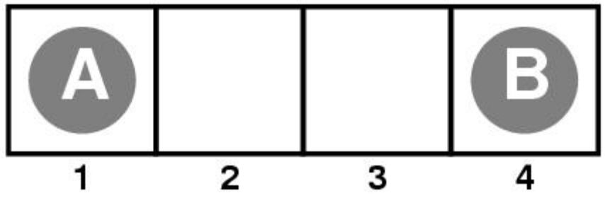

This is the starting position of a simple game. Player A moves first. The two players take turns moving, and each player must move his token to an open adjacent space in either direction. If the opponent occupies an adjacent space, then a player may jump over the opponent to the next open space if any (for example, if A is on 3 and B is on 2, then A may move back to 1). The game ends when one player reaches the opposite end of the board. If player A reaches space 4 first, then the value of the game to A is +1; if player B reaches space 1 first, then the value of the game to A is -1.

Hint: Here is the start of the tree. You may use this as a starting point for your answer.

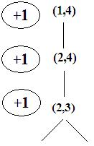
3.) (10 points) Suppose that an agent is in a 5 x 5 maze environment like the one shown in figure2 below. The agent knows that its initial location is (1,1), that the goal is at (5,5) and that the four actions, Up, Down, Left, Right have their usual effects unless blocked by a wall. Moreover, some locations have holes and should not be visited (the agent will fall to never recover). A map is given to the agent and so the agent does know where the walls are and where the holes are. The agent must arrive to the goal by the shortest path, counted as the number of sites visited. The agent uses as heuristics “the minimum number of sites needed to reach the goal, regardless of the existence of walls or holes”.

Apply the A* algorithm on a tree (chapter 4), starting from the state/node (1,1), as described above. Use the coordinates of the sites as the states. Build a tree search A* describing the fringe of the A* search, a list of states, as the algorithm progress from the root (node (1,1)).

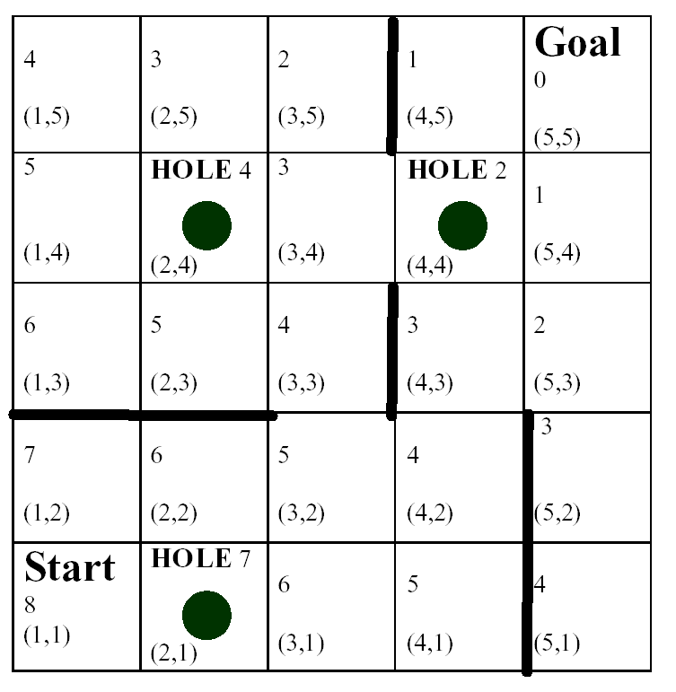

Figure 2: The maze where the agent will walk to the goal. We place the h cost, heuristic cost, at each square.

4. (5 points) Consider the following state space graph where the arcs represent the legal successors of a node, and all arcs are bi-directional, meaning the successor function can be applied from either node. The cost of moving to a successor node is given by the number on the arc. The value of a heuristic evaluation function, h, if computed at a state, is shown along side each node. The start state is S and the goal is G.

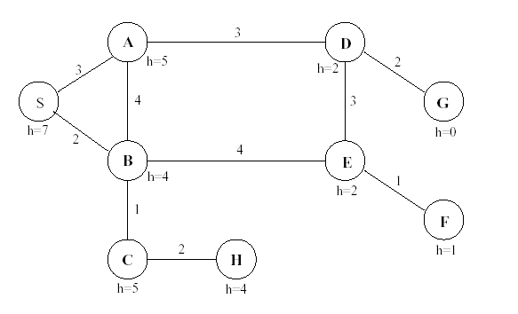

When a node is expanded, assume its children are put in the NODES list in alphabetical order so that the child closest to the front of the alphabet is removed before its other siblings (for all uninformed searches and for ties between siblings in informed searches). Do not generate a child node if that same node is an ancestor of the current node in the search tree. When selecting a node from NODES, in case of ties between non-siblings, use FIFO order to select the node that has been in NODES longest.

Give the sequence of nodes as they are removed from the NODES list (for expansion or before halting at the goal) for each of the following search methods.

(a) Uniform-Cost search

For example, the answer to this one starts out “S B A . . .”

(b) A* heuristic search

(c) Greedy Best-First search

